702396303

POSC 355 Urban Politics

Winter Semester 2018

Dr. Theodore J. Davis, Jr.

Effects of Urbanization on Climate Change

The goal of this research is to identify the correlating factors between climate change and urban environments. More specifically, special attention will be paid to the effects of climate change and why it is an issue, what has already been done in the fight against climate change, and the current standing of the climate crisis. This research draws upon mostly primary sources including published books, scientific findings, and government publications.

Before the industrial revolution, the bulk of the earth’s population lived in rural communities. Rural life and its contemporary issues were segregated from those of the city. As cities grew and expanded, the share of the world’s population living in cities rose from just 9 percent in 1900 to 30 percent in 1950 and then climbed to 52 percent in 2011. If present trends continue, by 2050 cities will be home to 66 percent of all humans on the planet (United Nations Population Division 2014). As a city’s population grows, the problems affecting it encroach on other communities, becoming not just an urban issue, but a global issue. Rural country dwellers are no longer able to ignore the ills affecting a city and instead must unite with urbanites to combat these issues. Perhaps the greatest issue brought about by the rising population in urban areas is the reality of climate change. Thus, it is imperative to understand the effects of climate change, the efforts that have been made to reduce our environmental footprint and humanities current standing in the climate crisis.

The adverse effects of climate change can be observed within any region on earth, however, the effects become exponentially worse when the focus is shifted to urban areas. To understand why this phenomenon occurs, one must be aware of the underlying causes and effects of climate change. One of the contributing factors to climate change is the depletion of the ozone layer. The ozone layer exists in the earth’s stratosphere, which is about 10 km above the earth. The ozone layer contains a high concentration of ozone, which absorbs ultraviolet (UV) radiation emitted by the sun. As the ozone layer depletes, more UV radiation reaches the earth’s surface. UV radiation has been linked to detrimental effects such as skin cancers, cataracts, destruction of crops and harm to marine life (epa.gov). The most prominent cause for the depletion of the ozone layer is the release of ozone-depleting substances (ODS) into the atmosphere. One example of an ODS is chlorofluorocarbons (CFCs). CFCs contain chlorine atoms, when these atoms come into contact with ozone in the stratosphere the ozone molecules are destroyed. One chlorine atom can destroy over 100,000 ozone molecules before it eventually dissipates (epa.gov). CFCs are most often found in aerosol cans, however, CFCs for use in aerosol products has been banned in many 1st world countries since the 1970s. Although CFCs have been banned in aerosol form for almost 50 years, the problem of ozone depletion still lingers as there are many other ODS besides CFCs such as hydrochlorofluorocarbons, carbon tetrachloride, and methyl chloroform (epa.gov). One quantifiable example of ozone depletion is the ozone “hole” over Antarctica. The ozone hole is a region which contains sparse ozone levels. Figure 1 is a map which shows the ozone hole on October 4, 2004, figure 2 shows the ozone hole on March 8, 1980. The data was acquired by the Ozone Monitoring Instrument on NASA’s Aura 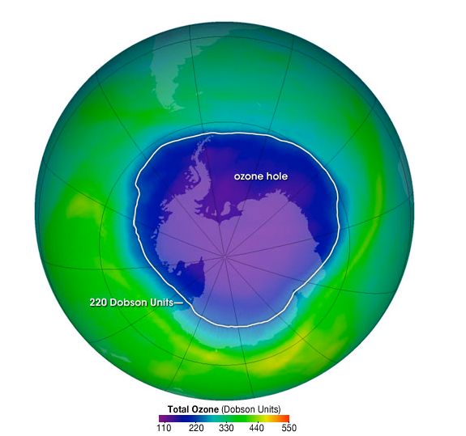satellite. The ozone levels are measured in Dobson Units (ozonewatch.gsfc.nasa.gov).

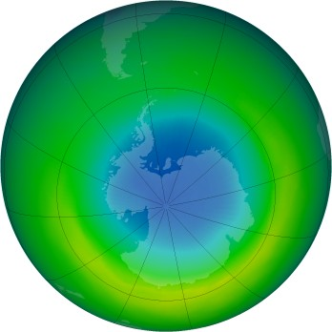

**Fig 1 Ozone Hole in 2004 Fig 2 Ozone Hole in October 1980**

The second most prominent cause of climate change, the greenhouse effect, is directly related to an increasingly urban environment. The greenhouse effect is a phenomenon which occurs when greenhouses gases (any gas that traps heat in the atmosphere) trap the sun’s radiation and prevent it from leaving, thus heating the earth. The greenhouse effect works in conjunction with the depleting ozone layer. As the ozone layer depletes, more radiation is able to enter the earth’s atmosphere. This radiation then becomes trapped by greenhouse gases and is unable to dissipate, thus heating the earth (climate.nasa.gov). The greenhouse gas effect is substantially worse in more densely populated areas. The reason for this is that there are simply more people releasing greenhouse gases within a given area. The most common and dangerous greenhouse gas is CO2. CO2 is released by burning fossil fuels, most commonly in automobiles. In an urban area, there are more CO2 emitters (cars, buses, factories, power plants, etc.) than in a less populated zone. This means there is more CO2 emitted per square mile, and thus a larger quantity is produced. The raising of the earth’s temperature has many disastrous effects on pedestrian life. A warmer climate enables the atmosphere to collect, retain and drop more water, changing weather patterns in such a way that wet areas become wetter and dry areas become drier (nrdc.org). According to Aliya Haq, a deputy director of NRDC’s (Natural Resources Defense Council) Clean Power Initiative, “Extreme weather events are costing more and more, the number of billion-dollar weather disasters is expected to rise”. A rising global temperature can also raise sea levels, which can lead to flooding of low-lying areas. By 2100, it's estimated our oceans will be one to four feet higher, threatening coastal systems and low-lying areas, including entire island nations and the world's largest cities such as New York, Los Angeles, and Miami as well as Mumbai, Sydney, and Rio de Janeiro (nrdc.org). Aside from heating the earth, rising temperatures can worsen air quality by increasing ground ozone. Ground ozone forms when various pollutants react with sunlight. This type of ozone forms just above the earth’s surface and is also the main component in smog (aircentraltexas.org). Smog, which derives its name from a combination of “fog” and “smoke”, is a form of air pollution that can cause asthma and pneumonia. The effects of smog are not something to take lightly, in 1952 a smog cloud engulfed London for 5 days, nicknamed The Great Smog of London. It is estimated that between 4,000 and 12,000 people died-many of them infants and the elderly. The smog cloud formed due to pollution emitted from a dense urban environment, as well as a lack of regulations regarding factory emissions (britannica.com).

As a densely populated urban area contributes to climate change, so too can a less densely populated area, in a process called urban sprawl. Urban sprawl refers to unorganized, sporadic, low-density developments beyond the edge of service and employment areas (Cities and Urban Life, 86). These spread out developments render public transportation obsolete. Buses would have to travel too far, wasting time and gas, only to pick up a small number of people. Thus, residents in low-density areas must rely on cars, increasing the number of automobiles in a given area, which in turn, increases the amount of CO2 released. Aside from increasing the volume of pollutants in the atmosphere, urban sprawl results in other adverse environmental effects. As new development begins across the countryside, it often disrupts wildlife habitats and fragments rural regions once abundant in farmland, fields, forests, lakes, and ponds. An example of the latter is the runoff from streets, parking lots, lawns, and farms that empties pollutants and sediment into waterways, degrading water quality and smothering habitats (Cities and Urban Life, 89).

As the effects of climate change steadily worsen, efforts to protect the environment have been undertaken by various governments. In the US, a new mode of development has been introduced called smart growth. Smart growth is the alternative to sprawl, it incorporates comprehensive land-use planning to revitalize and build compact, environmentally sensitive communities, ones that are transit and pedestrian-oriented and contain a mix of residential, commercial, and retail spaces (Cities and Urban Life 92). There are multiple modes of smart growth which attempt to combat the consequences of sprawl. The first mode is the implementation of urban growth boundaries. Urban growth boundaries are official boundaries around a city, where development outside this border is prohibited. The intent is to funnel growth into existing infrastructure, while at the same time protecting the natural resources which exist outside the urban area. In 1973, Oregon Governor Tom McCall convinced the Oregon Legislature to adopt the nation’s first set of statewide land use planning laws. On May 29, 1973, Senate Bill 100 was signed into law by Gov McCall, it included provisions for the nation’s first urban growth boundary. The boundary resulted in a 20 percent growth within its 5-mile diameter (oregonmetro.gov). Every 6 years, the city of Oregon revisits the existing boundary to determine if it needs to be expanded. Since the boundary’s implementation, it has been expanded more than three dozen times. Figure 3 shows 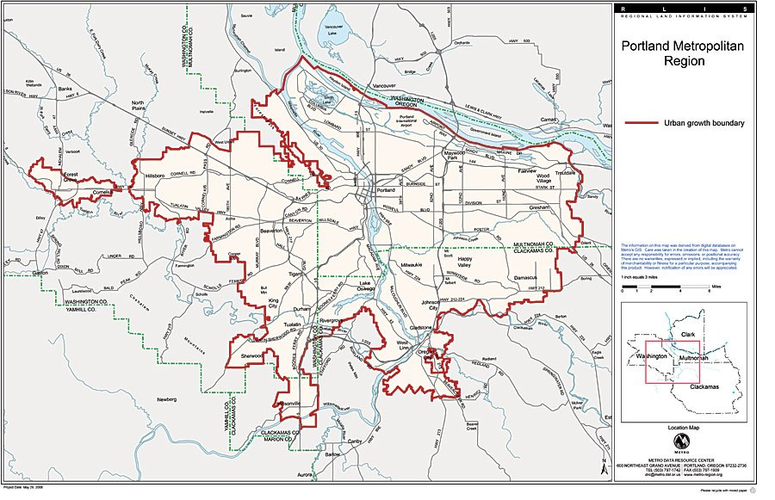the existing urban growth boundary in Portland as of May 2018.

**Fig 3**.

Smart growth also incorporates revitalizing existing towns and cities. The objective of this approach is to keep the area aesthetically pleasing, discouraging residents from moving. One of the methods used to achieve this goal is to relocate corporate giants outside residential areas. Corporate buildings are often simple and bland, utilizing only a few materials and simple shapes in their design. This gives them a dystopian ambiance, and can often discourage residents from living near them. Forcing corporate entities to relocate outside the city encourages a population influx into that city. Another method to revitalize existing towns and cities is by eminent domain. Eminent domain is the ability of a government to seize private property for public use, so long as the owner receives compensation for their property at market value. This use is extremely controversial and has been the subject of many supreme court hearings, the most prominent being the case of *Kelo v. The city of New London*. The city of New London had fallen of hard economic times, to revitalize their city, officials sought to buy 115 residential and commercial lots. 15 owners refused to sell their property, and the city condemned their property. These owners sued the city in the Supreme Court, arguing the city had abused its power of eminent domain. The Supreme Court ruled in favor of New London in a 5-4 vote, saying that governmental taking of private property for economic development constituted a permissible “public use” (oyez.org). New London has since seen an economic upswing and has begun the rebuilding process.

Smart growth also includes initiatives undertaken by cities in an attempt to reduce their environmental footprint. To reduce the “heat island” effect, where cities are hotter in summer than surrounding areas, cities such as Chicago and New York encourage green roofs instead of black-tar ones atop skyscrapers. Grass, shrubs and even small trees reduce the amount of energy needed to cool buildings and capture rainwater, thereby reducing the amount flowing into overtaxed sewers (Cities and Urban Life, 98). Other initiatives include replacing diesel fuel buses with hybrids, more efficient streetlights, more recycling bins to reduce waste, as well as improving cycling and walking infrastructure.

Strides of progress have been made since the discovery of the link between human activity and climate change, however, there is still more to be done. Domestically, climate change initiatives began in the 1970s. After several decades of increased public concern of the impact of human activity on the environment, President Richard Nixon proposed the creation of the Environmental Protection Agency. The EPA would become the primary regulatory agency involved with environmental protection in the United States. The goal was to enforce environmental protection standards, conduct environmental research and collaborate with other entities to curb environmental pollution. On December 2nd, 1970, the Environmental Protection Agency officially began operation (c-span.org). Shortly following the creation of the EPA, the destructive power of CFCs was first reported. In 1979 the patent for Freon (a CFC) was set to expire, this set the stage for a global debate on the banning of CFCs. In 1978, as the patent expiration date grew closer, the United States banned the use of CFCs in aerosol cans. This led to the creation of a lobbying group called the “Alliance for Responsible CFC policy”, its purpose was to combat regulations of CFCs. In 1986 however, the lobbying group reversed its stance and condemned the use of CFCs (toxtown.nlm.nih.gov). The United States also has a set of federal emission standards for engines and vehicles as established by the EPA. The ability of the EPA to regulate engine emissions—and the air quality in general—is based on the Clean Air Act (CAA) (epa.gov). The CAA was outlined in 1970 and amended in 1977, then again in 1990. Under the Clean Air Act, the EPA is required to regulate emissions of pollutants that "endanger public health and welfare". State and local governments also monitor and enforce Clean Air Act regulations, with oversight by the EPA. This legislation has a 40-year track record of cutting dangerous pollution and has prevented more than 400,000 premature deaths and hundreds of millions of cases of respiratory and cardiovascular disease (ucsusa.org).

There have also been various global efforts to protect the environment. Starting in the 1980s, efforts arose to reduce the consumption of CFCs worldwide. The Montreal Protocol was the first result of these efforts. The Montreal Protocol was finalized in 1987, it is a global agreement to phase out the use of CFCs. The United States ratified the protocol in 1988, and as of June 2015, all countries in the UN, as well as the EU, have ratified the protocol. The Montreal Protocol has proven to be innovative and successful and is the first treaty to achieve universal ratification by all countries in the world. Full implementation of the Montreal Protocol is expected to result in avoidance of more than 280 million cases of skin cancer, approximately 1.6 million skin cancer deaths, and more than 45 million cases of cataracts in the United States alone by the end of the century, with even greater benefits worldwide. The Montreal Protocol’s Scientific Assessment Panel estimates that with the implementation of the Montreal Protocol we can expect near complete recovery of the ozone layer by the middle of the 21st century (state.gov). More recently, efforts to reduce the global temperature have been introduced, namely the Paris Climate Agreement. This agreement is a non-binding agreement within the UN between 174 states. The agreement was signed in 2016 in New York, New York. The Paris Agreement central aim is to strengthen the global response to the threat of climate change by keeping the global temperature rise below 2 degrees Celsius. Additionally, the agreement aims to strengthen the ability of countries to deal with the impacts of climate change. To reach these ambitious goals, appropriate financial flows, a new technology framework, and an enhanced capacity building framework will be put in place, thus supporting action by developing countries and the most vulnerable countries, in line with their own national objectives. The agreement also requires all parties must report on their emissions and on their implementations (unfccc.int). In the US, the agreement was originally signed under the Obama Administration, however, on June 1st, 2017, President Trump announced the US would be withdrawing from the agreement, claiming the agreement hurts the US economy with a loss of jobs and vastly diminished economic production in key sectors (climateanalytics.org).

Until recently, most of the earth’s population lived in rural towns and villages. This has started to change in the past hundred years. Now, more than 50% of people live in an urban area and this percentage will only continue to rise. With these rapid new changes come new challenges that humanity must address. The most significant of these issues is undoubtedly the changing of the earth’s climate. Climate change is now affecting not only those in a city but the whole world. In order to combat the effects of climate change, we must understand why climate change is an issue, how it occurs and what actions we can take to mitigate the effects.

Works Cited

*U.S. Department of State*, U.S. Department of State, www.state.gov/.

“Climate Change: Vital Signs of the Planet.” *NASA*, NASA, climate.nasa.gov/.

“Explore Encyclopedia Britannica.” *Encyclopædia Britannica*, Encyclopædia Britannica, Inc., www.britannica.com/.

Garner, Rob. “New Results From Inside the Ozone Hole.” *NASA*, NASA, 24 Nov. 2015, www.nasa.gov/content/goddard/new-results-from-inside-the-ozone-hole.

Governments, Capital Area Council of. “Air Central Texas.” *Air Central Texas*, www.aircentraltexas.org/.

Macionis, John J., and Vincent N. Parrillo. *Cities and Urban Life*. Pearson, 2010.

“NASA Ozone Watch.” *NASA*, NASA, ozonewatch.gsfc.nasa.gov/.

“NRDC.” *NRDC*, www.nrdc.org/.

“Ozone Hole 2004.” *NASA*, NASA, ozonewatch.gsfc.nasa.gov/monthly/monthly_1980-10.html.

“Regulations for Emissions from Vehicles and Engines.” *EPA*, Environmental Protection Agency, 11 Jan. 2018, www.epa.gov/regulations-emissions-vehicles-and-engines.

“Tox Town | Environmental Health Concerns and Toxic Chemicals Where You Live, Work, and Play | National Library of Medicine.” *U.S. National Library of Medicine*, National Institutes of Health, www.toxtown.nlm.nih.gov/.

“UNFCCC.” *UNFCCC*, www.unfccc.int/.

“Union of Concerned Scientists.” *Union of Concerned Scientists*, www.ucsusa.org/.

“Urban Growth Boundary.” *Hello, Welcome to Portland*, 10 Mar. 2016, usp100portland.wordpress.com/urban-growth-boundary-2/.

“Watch Congress, White House & Courts.” *C-SPAN.org*, www.c-span.org/.

“Why Geoengineering Is Not a Solution to the Climate Problem.” *Climate Analytics - Preventing Dangerous Climate Change / Climate Analytics*, www.climateanalytics.org/.

“World Population Prospects - Population Division.” *United Nations*, United Nations, 2017, population.un.org/wpp/.

Young, Arashi, et al. “Metro.” *Metro*, www.oregonmetro.gov/.

“Oyez.” *Court Rulings*, www.oyez.org/.